A Major Project Proposal on

**WISE LIBRARY**

Submitted in partial fulfillment of the requirements for the degree of

Bachelor of Engineering in Software Engineering at Pokhara University

***By***

**NISHANTA PAUDEL**

**SANJAY PAHARI**

**SANJAYA ACHARYA**



**Department of Research and Development**

**GANDAKI COLLEGE OF ENGINEERING AND SCIENCE**

Lamachaur, Kaski, Nepal

**(December 2023)**

A Major Project Report on

**WISE LIBRARY**

Submitted in partial fulfillment of the requirements for the degree of

Bachelor of Engineering in Software Engineering at Pokhara University

***By***

**NISHANTA PAUDEL**

**SANJAY PAHARI**

**SANJAYA ACHARYA**

***Supervisor***



**Department of Research and Development**

**GANDAKI COLLEGE OF ENGINEERING AND SCIENCE**

Lamachaur, Kaski, Nepal

**(October 2023)**

# APPROVAL CERTIFICATE

This project entitled "**WISE LIBRARY**" is prepared and submitted by **"Nishanta Paudel",** "**Sanjay Pahari**"and "**Sanjaya Acharya**" under the supervision of "**Supervisor**" in partial fulfilment of the requirements for the Degree of Bachelor of Engineering in Software Engineering has been examined and is recommended for approval and acceptance.

**Date of Evaluation:** December 10, 2023

**……………………………………**

(Project Supervisor)

**…………………………………**

**Er. Rajendra Bahadur Thapa**

(Acting Coordinator)

**Research Management Committee**

**Gandaki College of Engineering and Science**

# ABSTRACT

In the dynamic landscape of digital literature, Wise Library transcends traditional boundaries by offering a unique platform that caters to both readers and authors. This web-based application not only provides users with a user-friendly interface to explore an extensive collection of books but also empowers authors to showcase their literary creations. Authors can effortlessly upload their works, categorize them as premium or free, and connect with a diverse audience of readers.

Wise Library’s innovative approach extends beyond conventional libraries by introducing a dynamic incentive system for authors. Authors can label their books as premium. This not only encourages a thriving community of authors but also ensures that readers have access to a diverse range of high-quality literature.

As Wise Library bridges the gap between readers and authors, it becomes a digital hub where creativity meets recognition. Readers can explore a rich collection of both free and premium content, while authors have the chance to share their work with a global audience and earn recognition for their contributions. Join Wise Library, where the exchange of knowledge and creativity is not only immersive but also rewarding for both literary enthusiasts and talented authors.

TABLE OF CONTENTS

APPROVAL CERTIFICATE i

ABSTRACT ii

CHAPTER 1 INTRODUCTION 1

1.1 BACKGROUND 1

1.2 PROBLEM STATEMENT 1

1.3 OBJECTIVES 1

1.4SPECIFIC OBJECTIVE 2

1.5 IMPLICATION 2

CHAPTER 2 LITERATURE REVIEW 3

CHAPTER 3 TOOLS AND METHODOLOGY 4

3.1 REQUIRED TOOLS 4

3.2 DESIGNS 5

3.2.1 USE CASE DIAGRAM 5

3.2.2 ENTITY RELATIONSHIP DIAGRAM 11

3.2.3 SYSTEM SEQUENCE DIAGRAM 12

CHAPTER 4 EXPECTED OUTCOME 13

CHAPTER 5 TIMELINE CHART 14

BIBLIOGRAPHY 15

WIREFRAMES 16

**TABLE OF FIGURES**

Figure 3.1: Use Case Diagram (UCD) of the system 5

Figure 3.2: Entity Relationship Diagram (ERD) for the system 11

Figure 3.3: System Sequence Diagram (SSD) of the system 12

Figure 4.1: Gantt Chart 13

# CHAPTER 1 INTRODUCTION

## 1.1 BACKGROUND

Wise Library revolutionizes the reading experience, offering readers a seamless platform to explore a diverse range of books, including premium and free content. Simultaneously, it provides authors with an opportunity to showcase their literary works, creating a dynamic space where readers discover the best books and authors gain visibility.

As readers immerse themselves in a curated collection, authors find a supportive platform to share their creations, fostering a community of literary enthusiasts. Wise Library serves as a digital nexus, connecting readers with captivating content and authors with a global audience, shaping the future of digital literature.

## 1.2 PROBLEM STATEMENT

Traditional library challenges for readers:

* Limited book availability.

Frequently requested books may have long waitlists, forcing readers to wait weeks or months before getting access.

* Constrained accessibility.

Traditional libraries can present significant challenges for readers, particularly those with disabilities or other accessibility needs.

* Lack of interactive features.

Traditional libraries may struggle to compete with digital platforms and apps that offer interactive features like multimedia content, interactive quizzes, and community forums.

Challenges for authors:

* Cost-effective publishing.

Cost-effective publishing poses several challenges for authors within the traditional library system, where the focus has historically been on physical print books rather than digital or self-publishing options.

* Real-time book updates

Traditional publishing involves lengthy production schedules, including editing, printing, and distribution, which can delay the release of updates or new editions. This timeline may not accommodate rapid changes or updates authors wish to make to their books.

## 1.3 OBJECTIVES

The general objective of our project is:

* To develop a web application for to implement digital library with personalized recommendation system.

## 1.4 SPECIFIC OBJECTIVES

* To manage books and authors.
* To enable author to publish their books either in two modes ; Premium or Free.
* To recommend readers books according to their reviews and history of borrowing.
* To enable the feature of online payment for borrowing premium books.
* To manage book reviews.
* To manage fine on late submission of books.
* To enable readers to mark their favourite books.
* To enable notification system.

## 1.5 IMPLICATION

Our web application, Wise Library, aims to revolutionize traditional library services by digitizing the book exploration experience. This not only provides users with the convenience of accessing a diverse range of books from any location but also offers opportunities for libraries to enhance their relationship with readers. Through a user-friendly web app, Wise Library engages readers with personalized recommendations, loyalty programs, and interactive features, fostering a sense of connection and loyalty beyond the physical library. This digital transformation has the potential to elevate reader satisfaction, boost engagement, and contribute to the growth of library services in the modern era.

# CHAPTER 2 LITERATURE REVIEW

Numerous web and mobile applications have been developed, offering platforms for diverse digital library experiences. Some noteworthy examples include:

**DigitalLibrary App:**

Allows users to explore a vast collection of books, offering personalized recommendations, interactive features, and seamless accessibility. (Digital Library , 2017)

**Libib:**

A web application fostering a sense of community among readers. Offers features like personalized book suggestions, interactive book discussions, and a user-friendly interface. (Libib, 2018)

**Lib-sys:**

Designed for book enthusiasts, providing a library of diverse genres, personalized book recommendations, and interactive reading challenges. (Libsys, 2014)

**NovelNook:**

A space for readers to connect and explore new literary worlds. Features include personalized bookshelves, real-time reading updates, and an engaging user interface. (Novel Nook Books, 2017)

# CHAPTER 3 TOOLS AND METHODOLOGY

## 3.1 REQUIRED TOOLS

The following tools will be used for the development of the application:

* Programming Languages
  + JavaScript (for overall application development)
  + Python (for implementing Machine Learning models)
* Library and Framework
  + React (for the frontend)
  + Node.js (for server-side development)
  + Scikit-learn (for ML model implementation)
* Database
  + MongoDB
* For Making Diagrams:
  + draw.io
* For Making Documentation and Presentation
  + Ms-Office

## 3.2 DESIGNS

### 3.2.1 USE CASE DIAGRAM

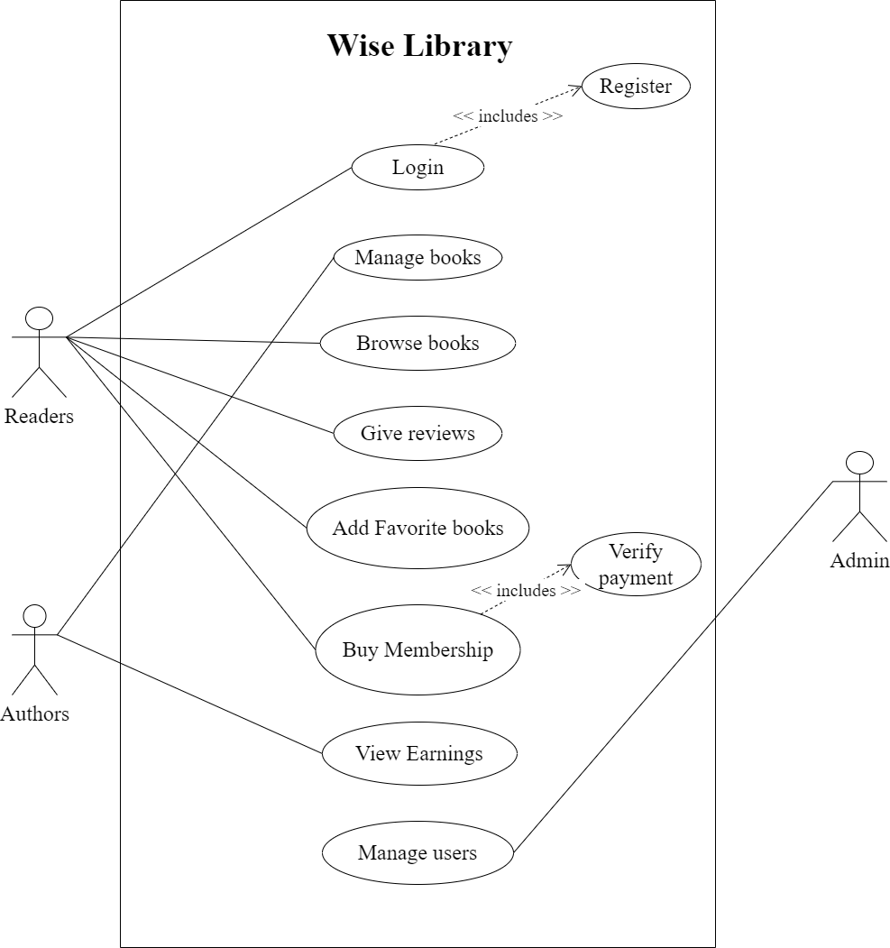

Figure 3.1: Use Case Diagram (UCD) of the system

**Use Case (UC1): Login**

**Primary Actor:** **Reader and Author**

**Pre-conditions:**

* The user has a registered account on the web app.
* The user has a stable internet connection.

**Post-conditions:**

* The user is successfully logged into their account.
* The user gains access to the menu, order placement, payment, and review features.

**Alternative Flow:**

* If the user enters incorrect login credentials, they receive an error message and are prompted to enter valid credentials.
* If the user forgets their password, they can select the "Forgot Password" option and follow the password recovery process.

If the user does not have an account, they can select the "Sign Up" option to create a new account.

**Use Case (UC2): Manage Books**

**Primary Actor: Author**

**Pre-conditions:**

* The author has a registered account on the Wise Library web app.
* The author is logged into their account.
* The author has a stable internet connection.

**Post-conditions:**

* The author successfully manages their books, including adding, editing, or removing them.
* Changes made by the author are reflected in the Wise Library database.

**Alternative Flow:**

* If the author encounters an issue while managing books, they receive an error message and are guided to resolve the problem.
* If the author wishes to remove a book:
* They select the book to be removed, and the system prompts for confirmation.
* Upon confirmation, the book is removed from the system.

**Use Case (UC3): Browse Books**

**Primary Actor: Reader**

**Pre-conditions:**

* The user has access to the Wise Library web app.

**Post-conditions:**

* The user successfully browses available books.

**Alternative Flow:**

* The user can refine their search by applying filters like genre or author.
* If the user encounters issues while browsing, they receive guidance to resolve the problem.

This use case enables users to efficiently explore and discover books within the Wise Library platform.

**Use Case (UC4): Give Reviews**

**Primary Actor: Reader**

**Pre-conditions:**

* The user has a registered account on the Wise Library web app.
* The user has read a book and wishes to provide feedback.

**Post-conditions:**

* The user successfully submits a review for the selected book.

**Alternative Flow:**

* If the user encounters issues while submitting a review, they receive guidance to resolve the problem.
* The user can include a rating along with their written review to enhance feedback.

This use case allows users to share their opinions and contribute to the Wise Library community by providing reviews for the books they have read.

**Use Case (UC5): Add Favorite Books**

**Primary Actor: Reader**

**Pre-conditions:**

* The user has a registered account on the Wise Library web app.
* The user is logged into their account.

**Post-conditions:**

* The user successfully adds selected books to their list of favorites.

**Alternative Flow:**

* If the user encounters issues while adding a book to favorites, they receive guidance to resolve the problem.
* The user can access their list of favorite books for quick reference and future reading.

This use case empowers users to curate a personalized collection of favorite books within the Wise Library platform for a tailored reading experience.

**Use Case (UC6): Buy Membership**

**Primary Actor: Reader**

**Pre-conditions:**

* The user has a registered account on the Wise Library web app.
* The user is logged into their account.

**Post-conditions:**

* The user successfully purchases a membership, gaining access to premium features.

**Alternative Flow:**

* If the user encounters issues during the membership purchase process, they receive guidance to resolve the problem.
* The user can explore and enjoy enhanced features such as exclusive book recommendations and advanced customization options after purchasing the membership.

This use case allows users to upgrade their Wise Library experience by acquiring a membership, unlocking additional benefits within the platform.

**Use Case (UC7): View Earnings**

**Primary Actor: Author**

**Pre-conditions:**

* The administrator has access to the Wise Library admin panel.
* The administrator is logged into their account.

Post-conditions:

* The administrator successfully views earnings and financial data related to the Wise Library platform.

**Alternative Flow:**

* If the administrator encounters issues while accessing earnings data, they receive guidance to resolve the problem.
* The administrator can analyse financial reports, track revenue, and gain insights into the financial performance of Wise Library.

This use case enables administrators to monitor and analyse the financial aspects of the Wise Library platform, facilitating informed decision-making and strategic planning.

**Use Case (UC8): Manage Users**

**Primary Actor: Admin**

**Pre-conditions:**

* The administrator has access to the Wise Library admin panel.
* The administrator is logged into their account.

**Post-conditions:**

* The administrator successfully manages user accounts, including creation, modification, or deactivation.

**Alternative Flow:**

* If the administrator encounters issues while managing user accounts, they receive guidance to resolve the problem.
* The administrator can perform actions such as creating new user accounts, updating user details, and deactivating or reactivating accounts as needed.

This use case empowers administrators to oversee and control user accounts within the Wise Library platform, ensuring effective management and adherence to platform policies.

### 3.2.2 ENTITY RELATIONSHIP DIAGRAM

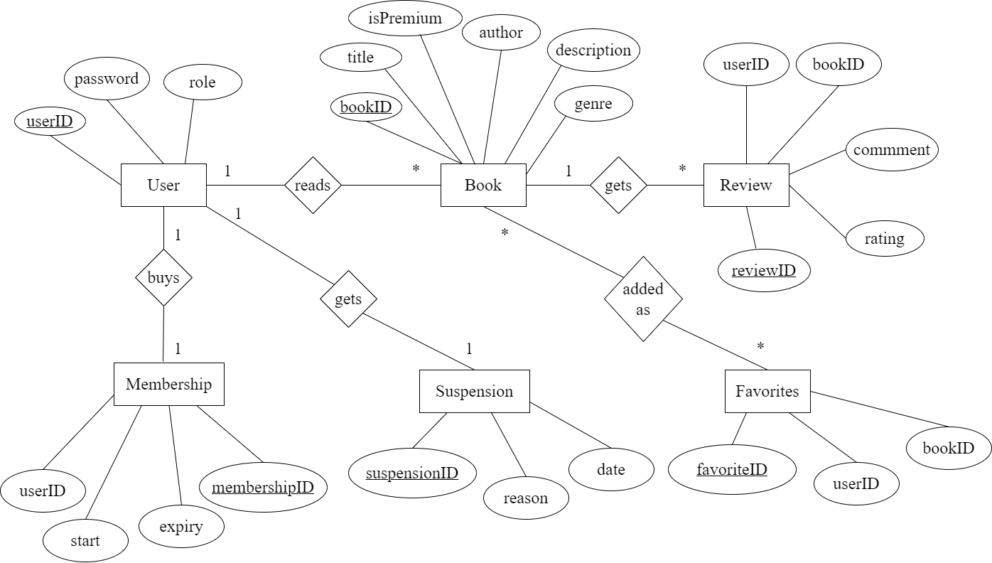

Figure 3.2: Entity Relationship Diagram (ERD) for the system

### 3.2.3 SYSTEM SEQUENCE DIAGRAM

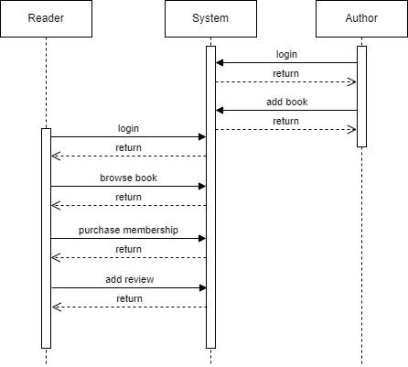

Figure 3.3: System Sequence Diagram (SSD) of the system

# CHAPTER 4 TIMELINE CHART

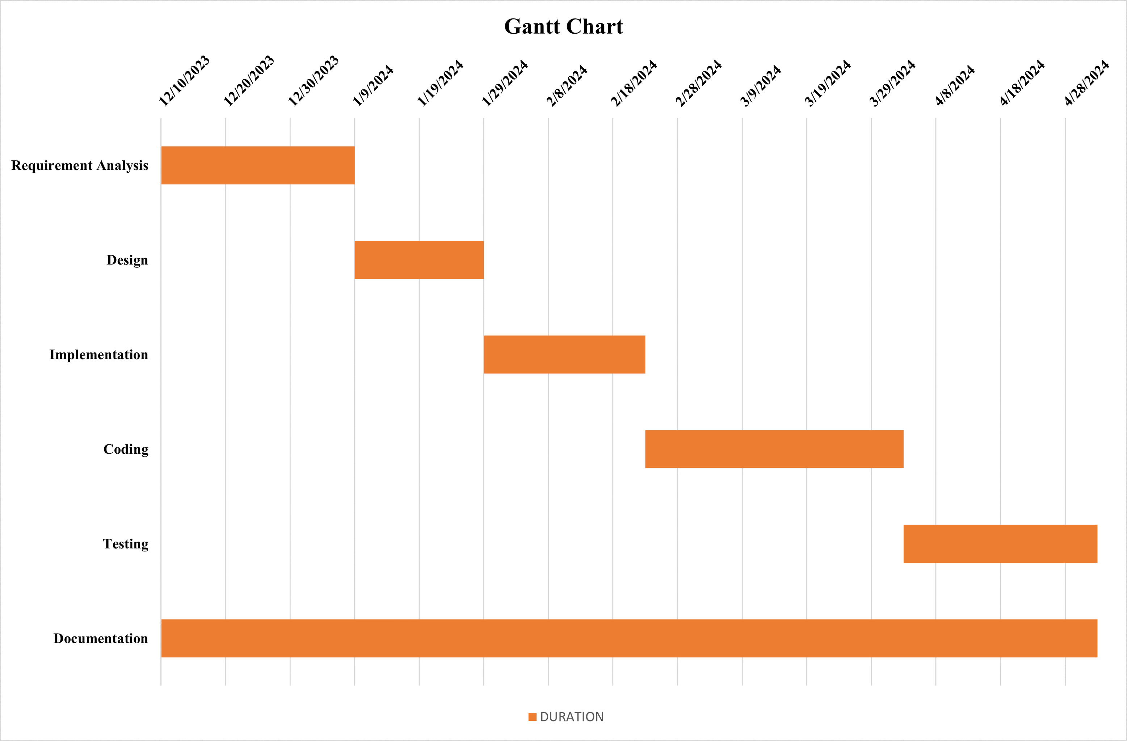

Figure 4.1: Gantt Chart

# BIBLIOGRAPHY

Digital Library . (2017, 4). *Aboutus | Digital Library* . Retrieved from https://digitallibrary.io/.

Libib. (2018, 12). *Blogs: Libib*. Retrieved from https://www.libib.com/.

Libsys. (2014). *Libsis | About*. Retrieved from https://www.libsys.co.in.

Novel Nook Books. (2017). *info_novelnookbooks*. Retrieved from www.novelnookbooks.com.

# WIREFRAMES

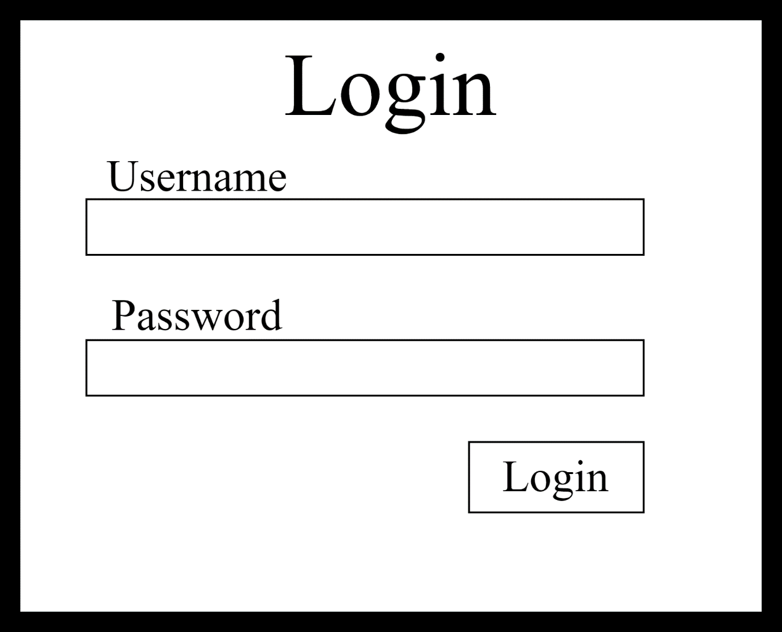

**Wireframe 1: Login Page**

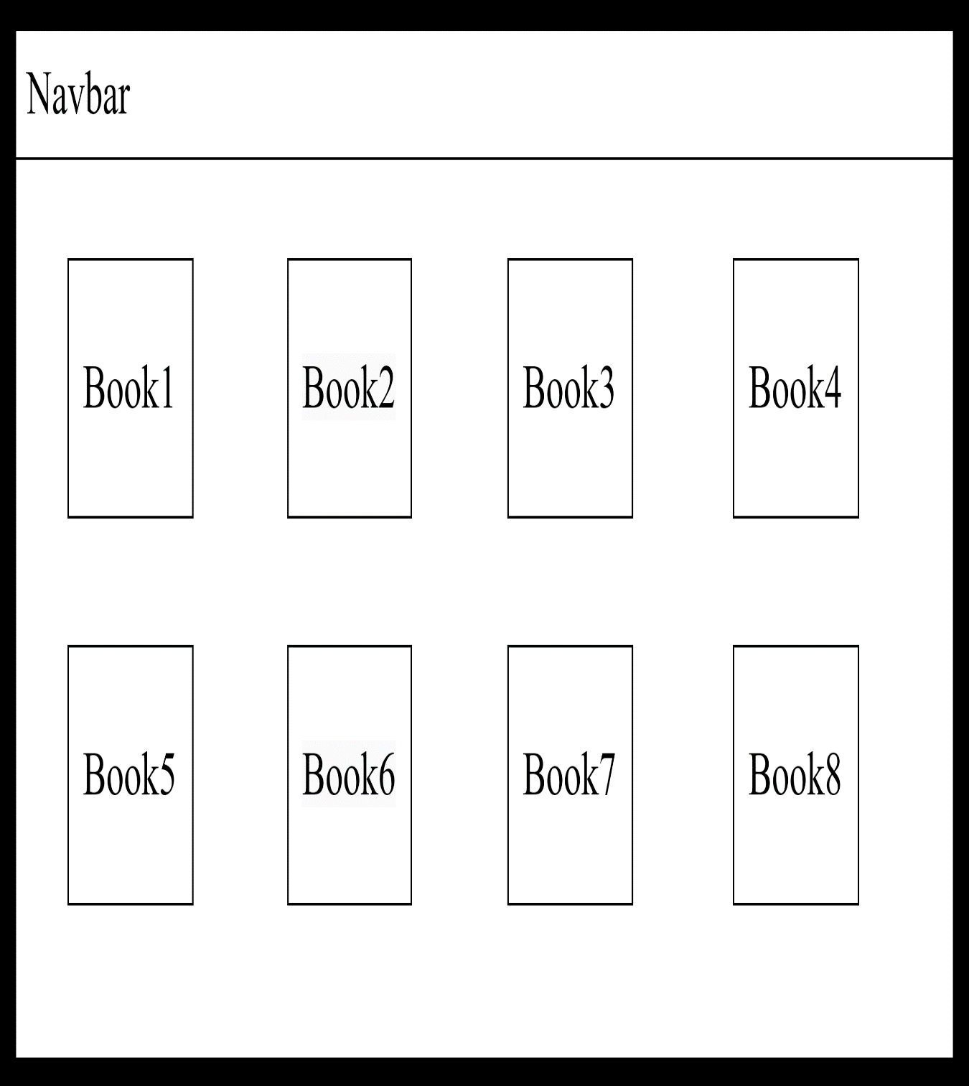

**Wireframe 2: Dashboard**

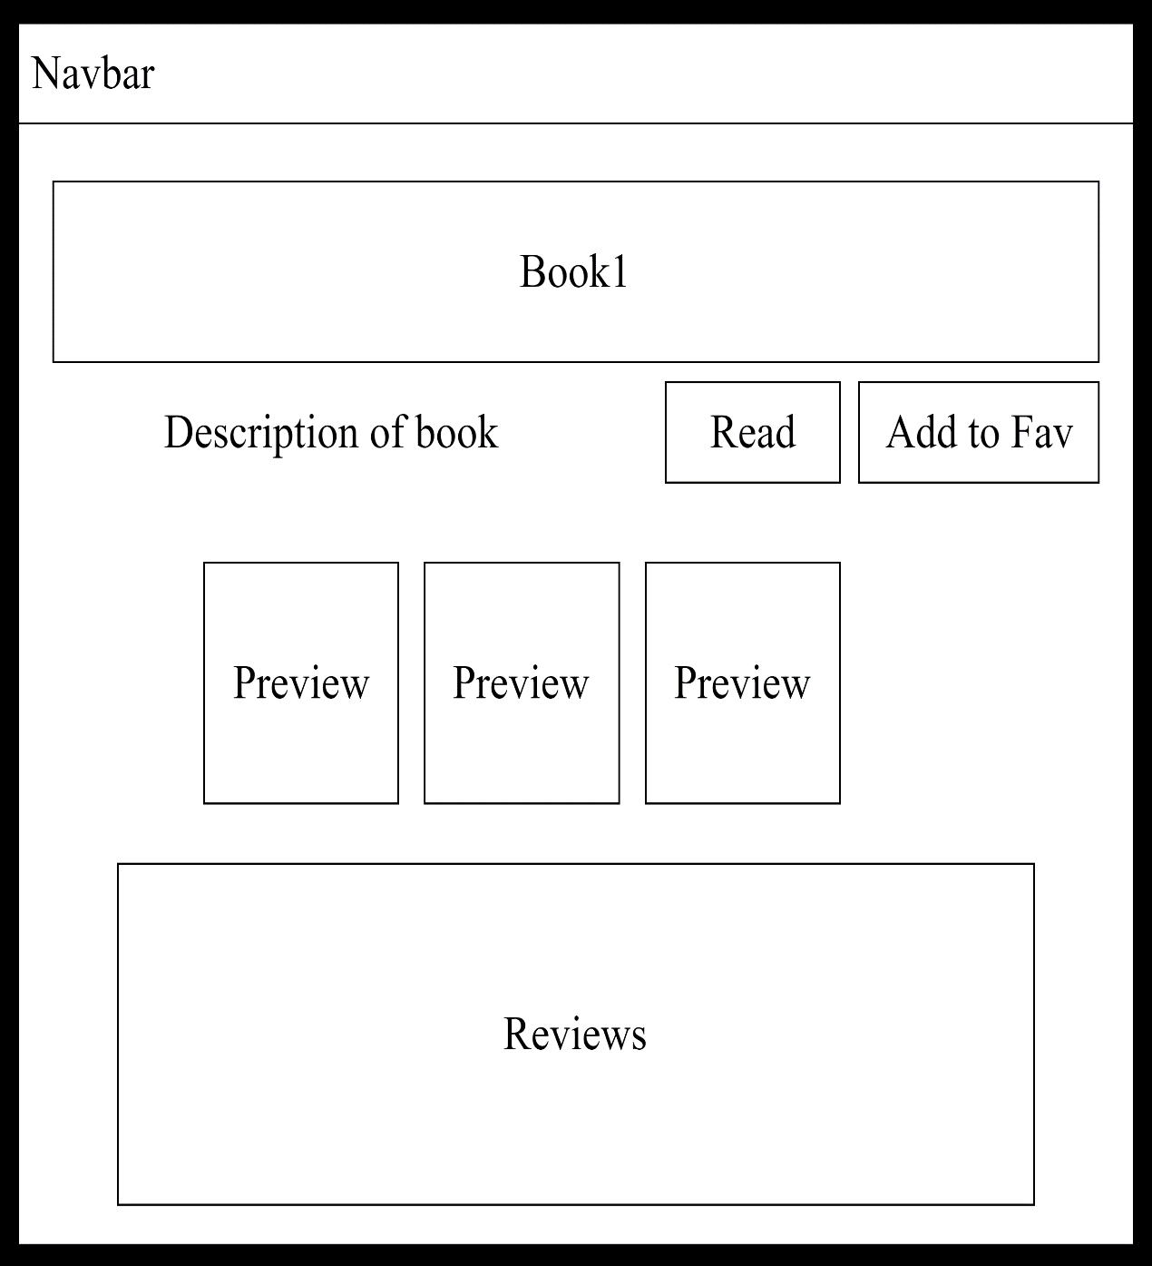

**Wireframe 3: Product Description Page**